We're going to cover some of the basics of simple image operations that we can do. Every video breaks down into frames. Each frame, like an image, then breaks down into pixels stored in rows and columns within the frame/picture. Each pixel has a coordinate location, and each pixel is comprised of color values. Let's work out some examples of accessing various bits of these principles.

We will start by reading in the image as usual (use your own if you can, but here's the one I am using here):

watch.jpg  
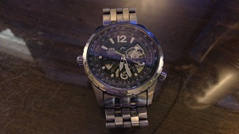

import cv2

import numpy as np

img = cv2.imread('watch.jpg',cv2.IMREAD_COLOR)

Now, we can reference specific pixels, like so:

px = img[55,55]

Next, we could actually change a pixel:

img[55,55] = [255,255,255]

Then re-reference:

px = img[55,55]

print(px)

It should be different now. Next, we can reference an ROI, or Region of Image, like so:

px = img[100:150,100:150]

print(px)

We can also modify the ROI, like this:

img[100:150,100:150] = [255,255,255]

We can reference certain characteristics of our image:

print(img.shape)

print(img.size)

print(img.dtype)

And we can perform operations, like:

watch_face = img[37:111,107:194]

img[0:74,0:87] = watch_face

cv2.imshow('image',img)

cv2.waitKey(0)

cv2.destroyAllWindows()

This will work with my image, but may not for your image, depending on the size. The output in my case:

